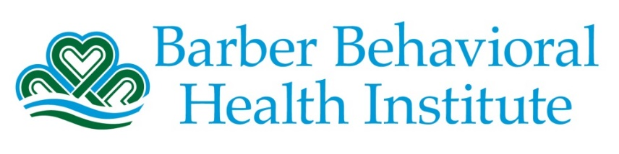

Connections Camp 2022
Goals and Objectives

Check 2-3 goals for your child to focus on during camp. If you select goal 2 or 4, also fill out the highlighted area.

Name | Click or tap here to enter text. | DOB | Click or tap here to enter text.
☐ | - Will learn and utilize coping skills  - Will learn about coping skills and how to use coping skills appropriately  - Will utilize coping skills appropriately and when needed to avoid increased negative feelings  - Deep breathing  - Mindfulness  - Will use learned coping skills and relaxation techniques to aid in regulating negative emotions  - Asking for a break  - Counting
☐ | - Will manage anger appropriately and will learn about anger management techniques  - Will manage anger in an age appropriate fashion instead of becoming aggressive or Click or tap here to enter text.  - Will learn the importance of using anger management techniques instead of becoming aggressive or Click or tap here to enter text.
☐ | - Will engage in and improve overall social skills (communication, play, etc) with peers, and engage in positive peer interactions  - Will engage in starting, engaging, and participating in conversations with peers  - Will maintain eye contact when engaging in conversations with teachers and peers  - Will have positive peer interactions by demonstrating  - Positive communication  - Appropriate Play  - Maintaining boundaries
☐ | - Will increase safety awareness in the camp and community settings  - Will demonstrate safety awareness by decreasing Click or tap here to enter text. behaviors  - Will learn about the importance of maintaining safe behaviors during camp and in the community settings

Form Completed By: | Click or tap here to enter text. | Date: | Click or tap here to enter text.

